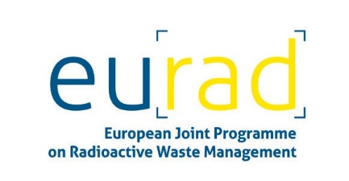

Digital Twins in Radioactive Waste Management

Free webinar on 16 February 2022, 13-16 CET

**Agenda:**

13:00 to 15:20 Presentations

13:00-13:10 Welcome & Introduction (N.N)

13:10-13:25 What are Digital Twins? (N.N.)

13:25-13:40 Digital Twins in PREDIS (N.N.)

13:40-14:00 Digital Twins in EURAD

-DONUT (N.N.)

-ACED (N.N.)

-HITEC (N.N.)

-MODATS (N.N.)

-FUTURE (Sergey Churakov, PSI)

*14:00-14:10 break*

14:10-14:25 Digital Twins in the Decommissioning Sector (N.N.)

14:25-14:40 Digital Twins in the Radioactive Waste Processing and Storage Sector (N.N.)

14:40-14:55 Digital Twins in the Radioactive Waste Disposal Sector (N.N.)

14:55-15:10 Digital Twins in the Construction Sector (N.N.)

*15:10-15:20 break*

15:20 to 15:50 Breakout Room Discussions

• What are the opportunities for digital twin technology in the radioactive waste domain?

• What are the challenges for adoption of digital twin technology?

• How can EURAD/PREDIS best assist successful deployment of digital twin technology?

15:50 to 16:00 Close

15:50-16:00 Feedback from breakout rooms / Summary and Conclusions

16:00 Adjourn

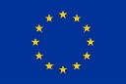

The EURAD programme has received funding from the European Union’s Horizon 2020 research and innovation programme 2014-2018 under grant agreement n°847593.

The PREDIS project has received funding from the EURATOM research and training programme 2019-2020 under grant agreement n°945098.